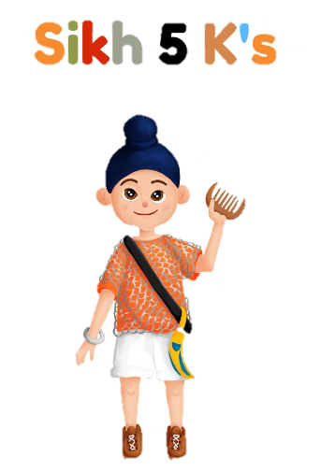

**Guru –** A Sikh teacher.

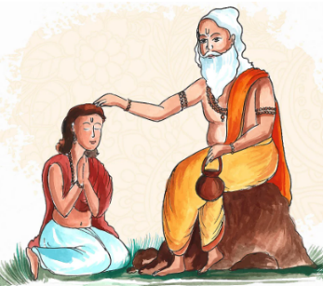

**Singh – Lion.** Males

**Kaur – Princess.** Females

**Khalsa –** To be pure and clear.

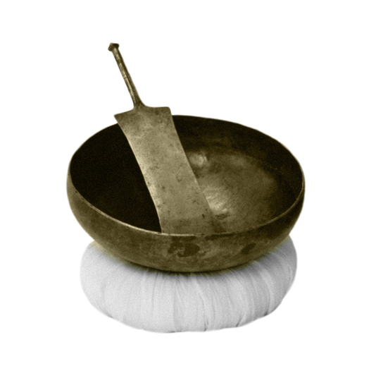

**Amrit –** A bowl of sugar and water.

**Amrit Sanskar** –

A ceremony where an initiate drinks Amrit from a bowl and has it sprinkled on their hair and eyes.

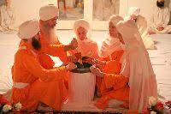

**Guru Gobind Singh**

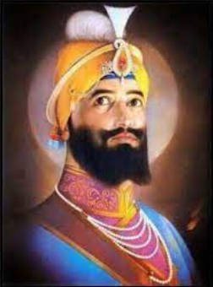

**Kara** – A steel bracelet.

**Kesh** – Uncut hair.

**Kanga** – A wooden comb.

**Kacchera** – Cotton underwear.

**Kirpan** – A steel sword. comb.

**Unit:** Sikhism, Khalsa

**Term:** Spring 2



**Vocabulary**