Learning Links:
Prior Learning: | Future Learning:
Empire – Year 4  Rise of Ancient Rome | Empire – Year 6 Queen Victoria’s Widowed Reign
Slavery – Year 2 Ancient Egypt
Law – Year 3 Rule of Law and Royal Power | Law - Year 6 The Rise of Nazi Germany
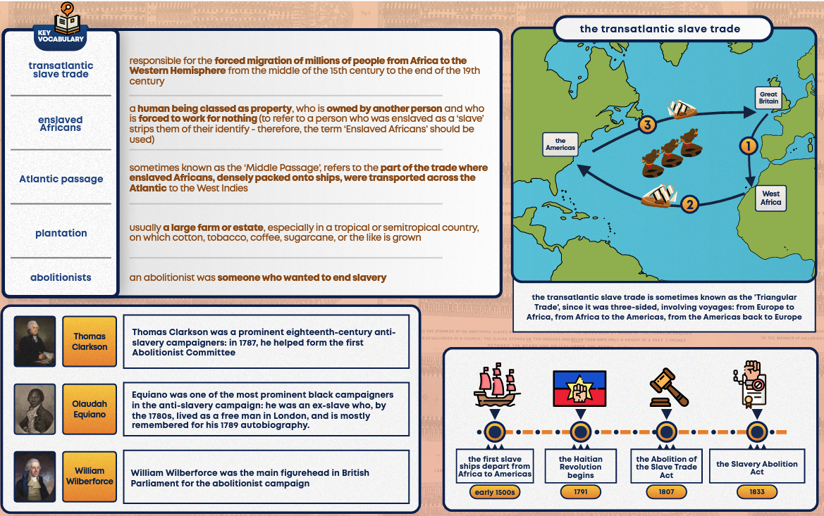
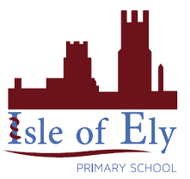
Unit: The Transatlantic Slave Trade
Term: Summer A

