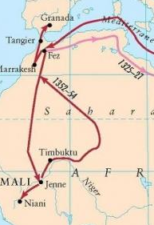
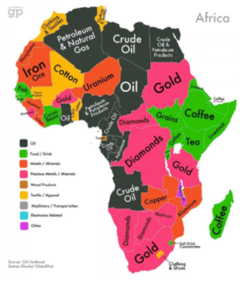
Natural resources of Africa
Geography Knowledge Organiser
Africa – Human Geography

Mansa Musa’s route to pilgrimage

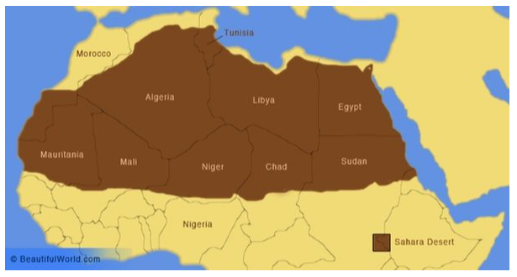
Key Vocabulary | Definition
Diverse | Showing a great deal of variety; very different.
Commodity | Something of value that can be bought or sold.
Desertification | A process where productive land, where many things can be grown, is turned into unproductive desert.
Food Security | People living in a country or area have no concerns about food, they have access to it, and they can afford it.
Infestation | Occurs when pests or parasites overrun a location.
Failed Crop | When the crops don’t grow.
Biomes | A large region of Earth that has a certain climate or certain types of living things.

