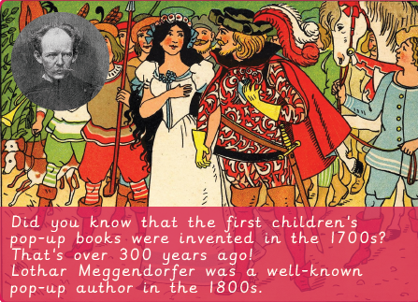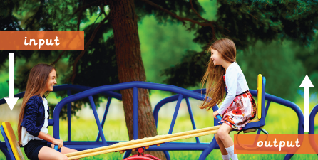 V2

The first children’s pop-up books were invented in the 1700s. Lothar Meggendorfer was a well-known pop-up author in the 1800s.

**Keywords:**

. **Aesthetic –** How an object or product looks.

**. CAD –** Computer Aided Design. To use the computer to design a product, diagram or drawing.

**. Caption –** A short piece of writing under a picture that describes or explains the picture.

**. Design –** To make, draw or write plans for something.

**. Design Brief –** A description of what you are going to design and make and how it will work.

**. Design Criteria –** To help designers focus their ideas and test the success of them.

**. Exploded-diagram –** A diagram which shows all of the part of a product, including the internal and external parts.

**. Function –** How an object or product operates or works.

**. Input –** The motion used to start a mechanism.

**. Linkage –** A set of bars linked together to form a mechanism.

**. Mechanism –** A system of parts working together.

**. Motion –** The movement an object makes when controlled by an input or output (e.g. left, right, up, down).

**. Output –** The motion that happens as a result of starting the input.

**. Pivots –** A shaft or pin on which something turns.

**. Prototype –** A simple model that lets you test out your idea, showing how it will look and work.

**. Sliders –** A part of a mechanism which allows an object to move from side-to-side.

**. Structure –** Something which stands, usually on its own.

**. Template –** A stencil made of metal, plastic or paper, used for making many copies of a shape or help cut material accurately.

**Design & Technology Knowledge Organiser**

**Pop-Up Books**



Key figures: