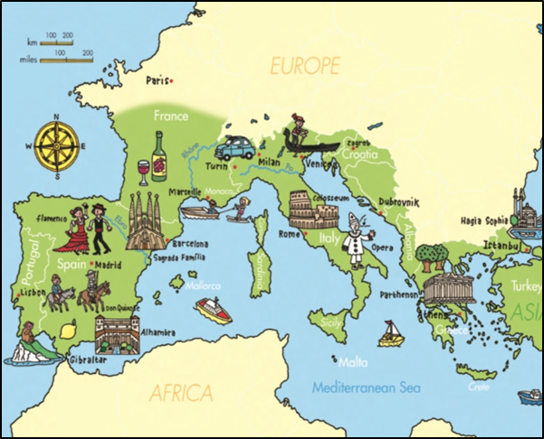
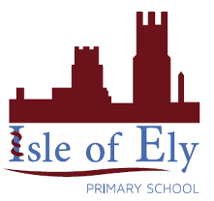
Knowledge Organiser
Year 4 – Summer Term A
Geography – Mediterranean Europe
Country | Capital | Language | Flag
Italy | Rome | Italian | 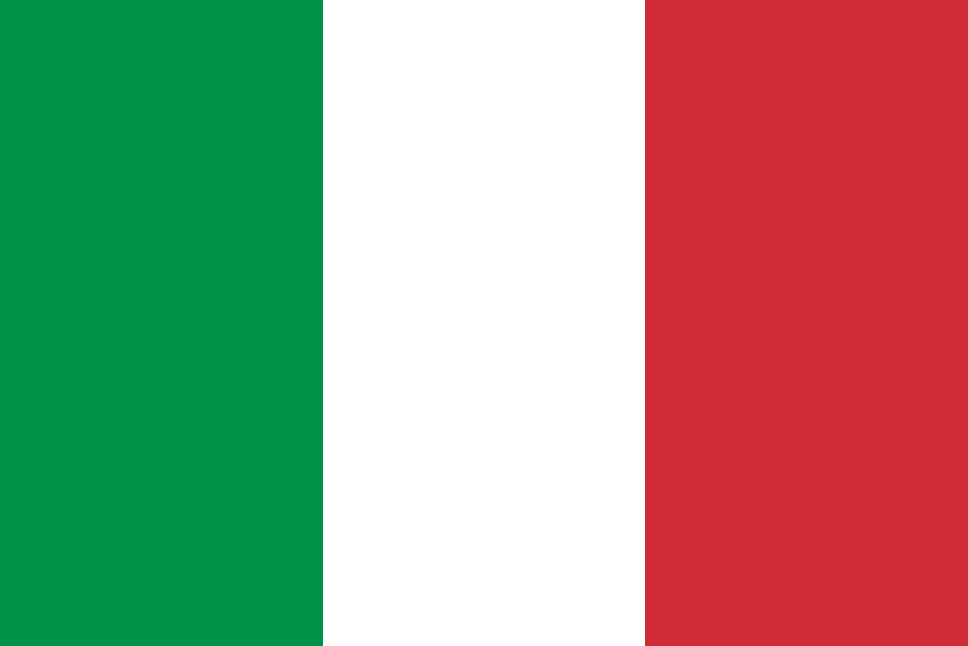
Spain | Madrid | Spanish | 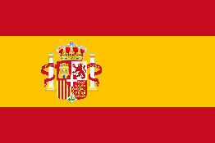
Portugal | Lisbon | Portuguese | 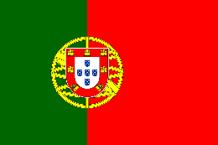
Greece | Athens | Greek | 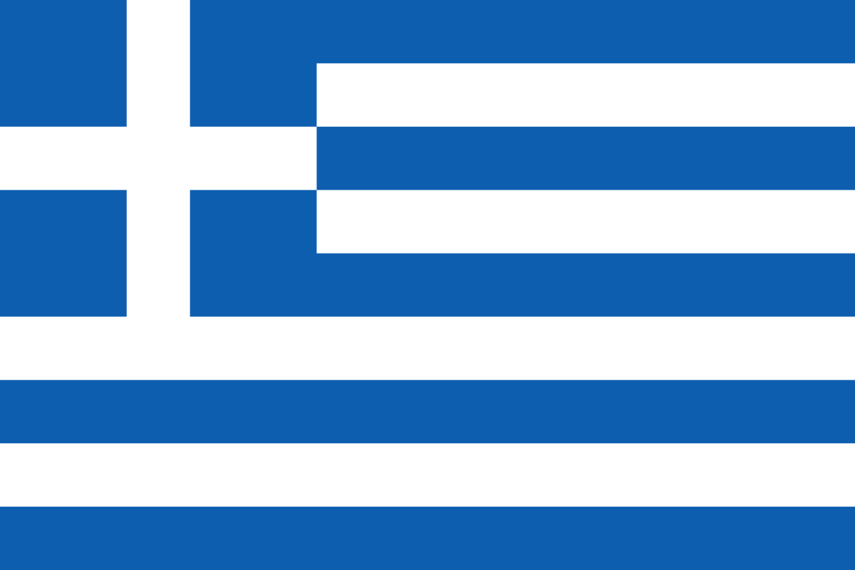
Turkey | Ankara | Turkish | 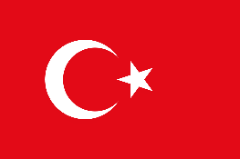
France (Southern) | Paris | French | 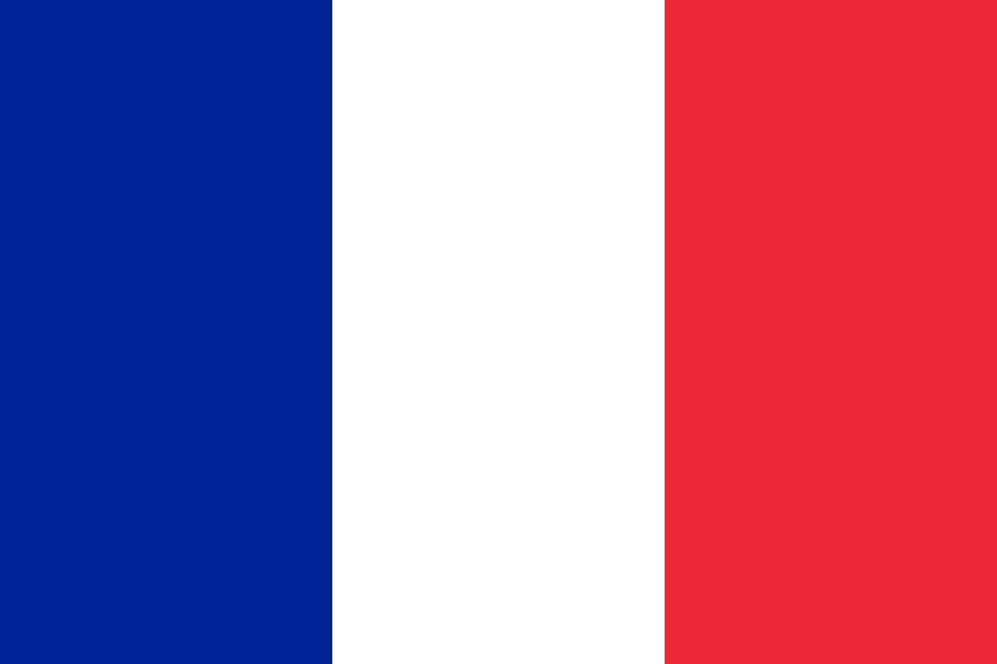
Malta | Valletta | Maltese

Vocabulary
Mediterranean | From the Latin meaning ‘middle of the land’.
Equator | An imaginary line around the ‘middle’ of the Earth. The sun’s rays hit the equator directly, making the places located near to it very warm.
Latitude | Latitude is a measurement that gives the location of a place on Earth north or south of the equator. Maps sometimes show imaginary lines of latitude to help us locate places.
Ecosystem | A community of plants and animals found in a particular area.
The Gulf Stream | A current of warm water that flows from the Gulf of Mexico in Central America, all the way across the Atlantic Ocean to Europe.
Colosseum | An ancient, giant, oval shaped amphitheatre located in the centre of Rome. It was built during Ancient Roman times and gladiators fought there.
Peninsula | A region of land that sticks out in a body of water, with water on three sides.
Inhabit | To live or dwell in a place, as people or animals.

