What plants need |  | Seeds
What do plants need?  - Water  - Light  - Warmth  - Space  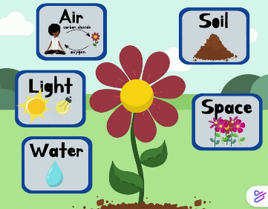  What happens if they don’t have these? |  | Let’s explore all the ways seeds spread:  - Wind  - Animals  - Water  - Humans  - Some seeds even explode.  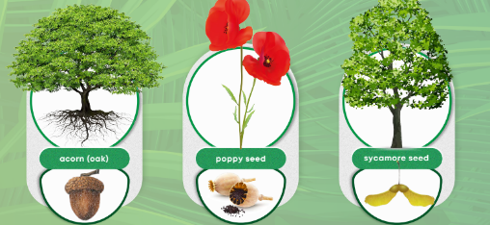  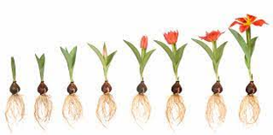
Parts of Plants |  | Deciduous and Evergreen
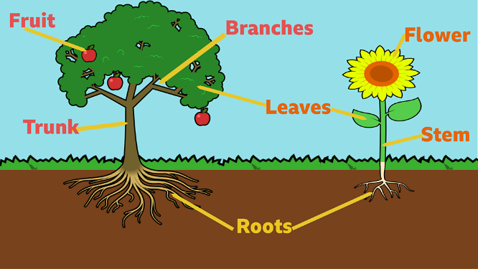 |  | Evergreen – A plant that retains green leaves throughout the year.  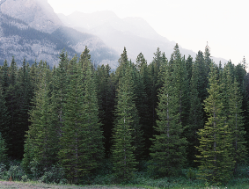  Deciduous – A plant that shreds its leaves annually (yearly).  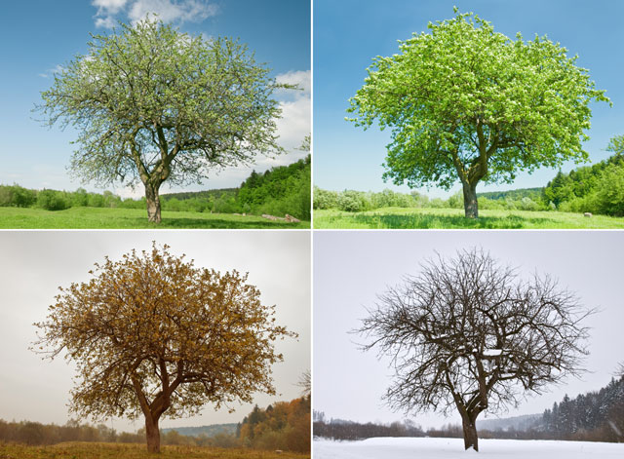
Knowledge Organiser
Summer Term 1
Science = Plants
Vocabulary
plant | A living thing that grows in one place, such as an oak tree,  a sunflower or a tomato plant
stem | The part of the plant that grows above the ground; the leaves and flowers grow from the stem which also transports water and  minerals around the plant
seed | The small part of a flowering plant that grows into a new plant
root | The part of a plant that acts as an anchor, fixing the plant into the ground, and they also absorb water and minerals to help the  plant to grow
leaves | A plant’s leaves absorb sunlight and turn it into energy that the plant uses to grow
deciduous | A tree that sheds its leaves during autumn
evergreen | A tree that keeps its leaves all year around

