Did you know? |  | Key Facts
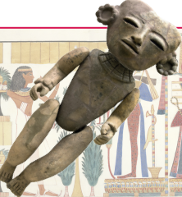  Puppets were first invented over 3,000 years ago in Egypt. They were made out of clay. |  | You will use a variety of techniques to create your puppet including:  - cutting  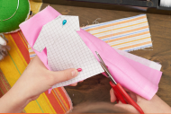  - gluing  - stapling  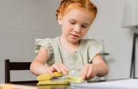  - pinning  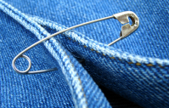
Key Questions
What colour fabric will you choose for your puppet?

What colour hair will your poppet have?

What kind of eyes, nose and ears will your puppet have?

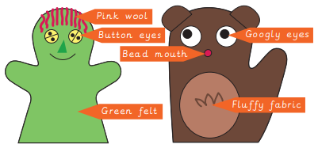
Knowledge Organiser Spring 2
Design Technology – Puppets
Vocabulary
Decorate | To add details to a design to improve its appearance
Design | To make, draw or write plans for something
Fabric | A natural or man-made woven or knitted material that is made from plant fibres, animal fur or synthetic material
Glue | A sticky liquid that can join two things together
Model | A practical version, often on a smaller scale, that lets you test out your idea and see how it will look and work
Hand puppet | A toy that you can make move by putting your hand inside it
Safety pin | A ‘U@ shaped pin with a cap where the needle slots in securely after fastening
Stencil | A shape that you can draw around
Technique | A way of doing something to complete a task
Template | A stencil which you use to help you draw a shape more easily on to different materials.

