Learning Links:
Prior Learning: | Future Learning:
Tyrant- Law and Power (Y3) | Overthrow- China – Dynasties and Conquerors (Y5)
Civil War- War of the Roses (Y3) | Heir, succession- The Victorian Age (Y6)
Religion- The Romans in Britain (Y2) | Union- The Rise and Fall of Hitler (Y6)
Vocabulary
The Gunpowder  Plot | A plot, led by Robert Catesby, to blow up the Houses of Parliament on the 5th November 1605.
Divine right of kings | The belief that kings are chosen by God and therefore should have all the power.
The Restoration | The Restoration of 1660 marked the return of Charles II to the throne after the Commonwealth (when England didn’t have a king).
Union of the  Crowns | When King James VI of Scotland became King James I of England, this united the two kingdoms under one crown.
Parliamentarian | Also known as the Roundheads: fought on the side of Parliament during the English Civil War.
Bubonic plague | A disease which causes painful, swollen lumps, black hands and feet and flu-like symptoms.
Royalist | Also known as Cavaliers: fought on the side of King Charles I during the English Civil War.
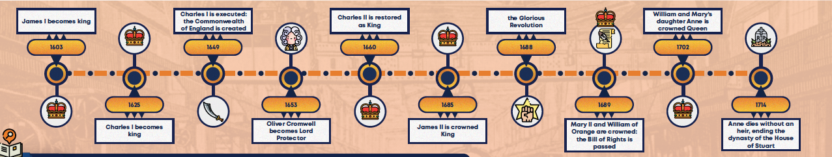
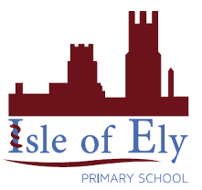
Key Figures
James I – King of England, Scotland and Ireland, from 1603-1625.
Robert Catesby – Leader of the Gunpowder Plot
Guy Fawkes – Caught planning to blow up the Houses of Parliament and executed.
Charles I – Son of James I: King from 1625-1694
Oliver Cromwell – Lord Protector from 1653-1658
Charles II – Son of Charles I: King from 1660-1685
Christopher Wren – Architect who rebuilt London after the Great Fire of London
Samuel Pepys – Wrote a famous diary

James II – Brother of Charles II: King from 1685-1688
Mary II – Daughter of James II: Queen from 1689-1694
William of Orange – Husband of Mary II: King from 1689-1702
Anne I – Sister of Mary: Queen from 1702-1714
Timeline
Unit: The Tudors
Term: Summer A

