Knowledge Organiser
Summer Term A
RE: Christianity: Jesus and Celebrations

Vocabulary |  | 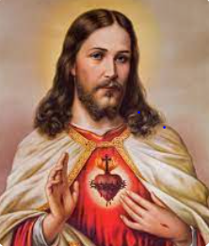  Jesus of Nazareth
Christianity | A religion based on the life and teachings of Jesus.
Disciple | A follower of Jesus during his life.
Faith | A strong belief in the teachings of a religion.
Baptism | People are washed in water to wash away their sins.
Sins | An offense against religious or moral law.
John the Baptist | The prophet who baptised Jesus.
Lent | A period of forty days where Christians remember the events leading up to the death of Jesus.
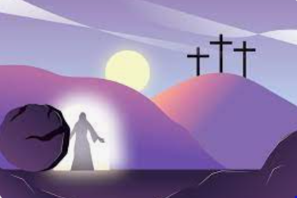
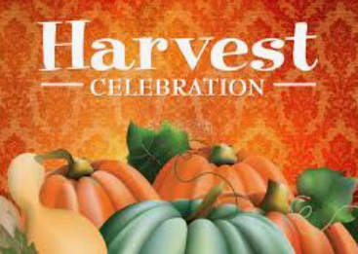
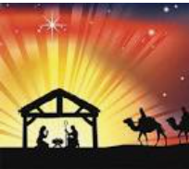

Christmas- When Jesus was born.
Easter- The resurrection of Jesus.
Harvest celebration- A time to thank God for the food that has been produced that year.

