Learning Links:
Prior Learning: | Future Learning:
Hierarchy:  Kings, Queens and Leaders (Y1)  Parliament and Prime Ministers (Y1) | Hierarchy:  Anglo Saxons (Y3)  Law and Power (Y3)
Civilisations:
Anglo Saxons (Y3)
Ancient Greece (Y3)
Prehistory | Prehistory is a large period of time in our past before humans could write.
Iron Age | a prehistoric period that followed the Bronze Age, when weapons and tools came to be made of iron.
Bronze Age | - a prehistoric period that followed the Stone Age and preceded the Iron Age, when weapons and tools were made of bronze rather than stone.
Neolithic | relating to or denoting the later part of the Stone Age, when ground or polished stone weapons and implements prevailed.
Mesolithic | part of the Stone Age, between the Palaeolithic and Neolithic.
Must Farm | Must Farm is a Bronze Age archeological site consisting of five houses raised on stilts above a river and built around 950 BC in Cambridgeshire, England.
Excavation | Excavation means to dig up.
Settlement | A place where people live.
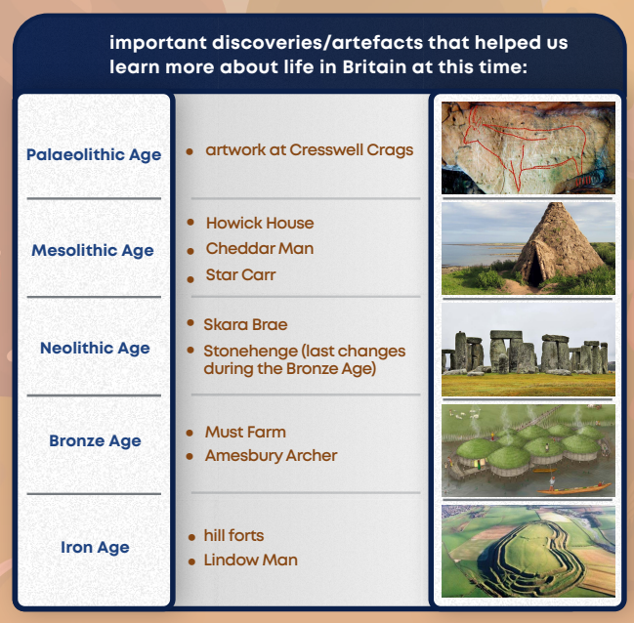
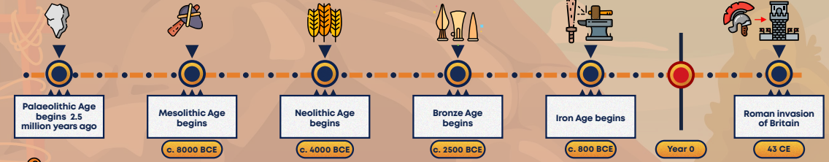
Timeline
Vocabulary
Unit: The Bronze Age
Term: Summer 2

